* **Title - Burrito Buddies**
* **Genre - Infinite shooter**
* **Expected ESRB Rating (E-Everyone)**
* **Time Interval - Realtime**
* **Platform Windows PC**
* **Player Mode - Single**
* **Camera Perspective - Top Down**
* **Target Audience - 8 and up**

**Concept Statement:** The concept of the game is to defend the little desert town from an invading alien hoard of burritos using Tabasco sauce to defend the town.

**Gameplay Summary:** The infinite shooter allows the player to navigate anywhere in the world and fight off the advancing enemies. Level advancement will be based on a scale and as the player achieves a level, the next one will require more points on each level. The goal is ward off the invading burritos and save the town from annihilation and destroy the mother ship that has landed. The player starts out with three antacid pills and is able to achieve extra lives (up to 6) by collecting a specific count of jalapeno peppers. As the player advances levels, the enemy burritos also gain in strength and require more hits to kill them.

**Look and Feel:** As a topdown shooter, the player will be able to get a 360 degree perspective of the enemies advancing and provide defensive fire where needed. The environment will be have a desert theme with a sandy terrain, cactus, rocks, bones, and tumbleweeds.

**User Interface:** Surrounded by burritos, the player has to fend off waves of invading monsters.

~~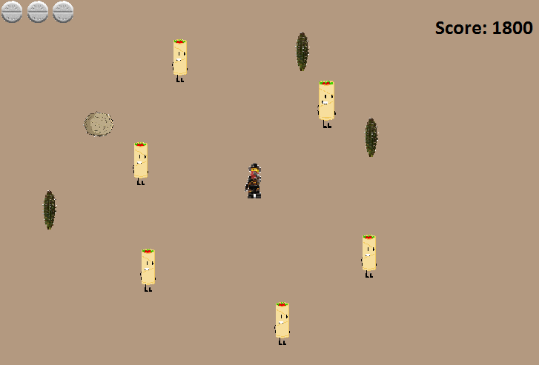~~

**UI Layouts:**

Main menu

Start

options

exit

TITLE

Options: in development

HUD

HEALTH

Score: 0000

**Tutorial:**  The tutorial will slowly introduce the player into how to move and navigate around the environment. Then when a burrito is presented, a dialog is shown to instruct the player in how to fire their Tabasco sauce and defeat the new found enemy. Depending on the strength of the burrito, multiple shows will be required to reduce their health to zero. The player will then be shown that the burrito can drop a random bonus item that when picked up, provides a significant benefit to the player which can include multi-shot, hotter sauce resulting in a quicker death for the burrito, etc. Next the player will be introduced to tumbleweeds that randomly appear that can a massive power up which clear the current screen of all burritos. Additional information will be provided instructing the player that once the number of burritos clear on the map is reached, the mega burrito appears for one final attempt to take over the town.

**Competitive Analysis:** Competitive titles include Livelock, HellDivers and Zombie Estate.

Livelock puts the player in control of a robot battling other robots in a post cataclysmic event in an environment with dynamic lighting and various urban settings. This game genre is developed specifically to the PS4 and will not have any direct impact on this game development with the Windows PC market.

HellDivers is developed for the Sony console platforms and offers cooperative play which, while not directly competing, would be a foundation to provide a multi-player capability later on. HellDivers is also geared toward team objectives while BurritoBandit is mainly focused on single player goals.

Zombie Estate is also a multiplayer game, however, the number of enemy hoards provides an equivalent experience although it is developed for the XBox and while it does have some form of a windows related platform, it shouldn't be any direct competition for the Windows PC.

**Game Rules:** The victory condition is achieved when the main ship that brought the burritos is destroyed while the loss condition occurs when all the ant-acids have been used up. Additional game rules for average game play includes:

* Defeating burritos adds to your score.
* Defeated burritos sometimes drop power ups.
* Getting attacked by burritos loses you a life, of which you start with 3 (max6).
* At zero life you lose and the high score is saved.
* If you beat the final boss win and your score is saved for champion status.

**Challenges:** The challenges include:

* Swarms of burritos plague the map, defeat as many as you can to get a high score.
* Defeat the level boss, to progress to the next stage
* Player must keep track of health, and not recklessly rush into the fray.
* Power ups might give the player the edge they need.

**Synopsis:** In an unsuspecting on horse town in the middle of the desert, the inhabitants find themselves in the grips of an invading hoard of alien burritos. Among these citizens is a stranger trying to get away from his troubles only to find himself in the middle of an invasion and the only one with the courage to fight them off.

**Characters and Enemies:** The main character is the Bandit, Pedro, that finds himself in the middle of an alien invasion while trying to get away from his troubles elsewhere. Little does he know that the alien burritos are intent on taking over the world and initiating their invasion in a small desert town that no one would suspect. Pedro must fight off the invading burritos using Tabasco sauce that by some coincidence, always has enough in his holster. Bonus points are obtained by hitting the tumbleweeds that tend to roll by. The burritos can come from any direction so Pedro must always be on guard to protect himself and the town. The burritos are relentless and often send MegaBurritos to prevent Pedro from protecting the town and ultimately the planet.

**Gameplay Flow Map:** Game flow would consist of the following concepts:

* Main menu -> Intro(optional) -> main Game -> :
  + pause menu -> main game or main menu
  + fail/victory screen -> main menu
  + cut-scenes

**Detailed Gameplay Mechanics:** The main concept will be level-reliant with the following characteristics:

* Player
  + Health (lives)
    - Starts at 3
    - Max 6
  + Can attack with projectiles at a fixed rate of fire.
* Burritos
  + Removes player health(lives) on contact
    - Has a max damage rate
  + Starts a 1 health
    - Increases amount as the levels progress
* Peppers
  + Increases either score or damage for a fixed period of time.
* Boss
  + Varies for each level.
  + Defeat it to reach the next level

**Ten-Minute Walkthrough:** The game loads the main screen where the player can set options before play, after which a brief intro plays describing the plight of the town. From there, the player will fend off waves upon waves of burritos at Pedro in order to defeat the defender of the town. Once each wave is completed, the mother ship sends out a mega burrito to once again defeat Pedro. When the boss is defeated, Pedro can advance to the next level.